|  |  |  |  |
| --- | --- | --- | --- |
|  | **COLLEGE OF COMPUTING AND INFORMATION SCIENCES** | | |
| **Assignment-02** | | |
| **Class Id** | 111728 | **Course Title** | OOP |
| **Program** | BSCS | **Campus** | North |
| **Date** | 06-06-2023 | **Total Marks** | 10 |
|  |  | **Faculty Name** | Ramzan Ali Butt |

# Instruction:

* Create a **word document** which contains each question’s

solution with screen shot of output.

* Must attempt all questions by yourself, in case of **copied** solutions your assignment will marked **ZERO.**
* Submit softcopy on **LMS** before deadline.

Save your word document with name: [Student Name Student ID] Submission Deadline: 10/06/2023

# Question – 1 [WINDOWS FORM BASED] [5 marks]

Create a quiz application for two types of student “junior students / senior students”. For both you have to create two levels of quiz question. [High/medium]. Each level contains 5 quiz question and each question contains 3 answers options it’s very simple, now run your mind to create GUI and:

# Apply OOP concepts:

1: classes

2: Constructor overloading

3: static keyword

4: methods

Use an appropriate GUI controls to create a best design from your side.

Show the correct answers and wrong answers at the end of the quiz program.

[Add screen shots of code and screen shots of outputs]

**Outputs**

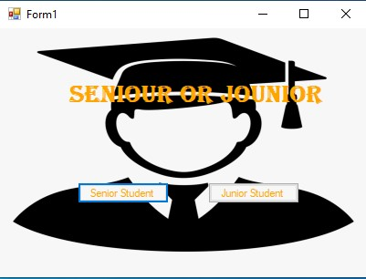

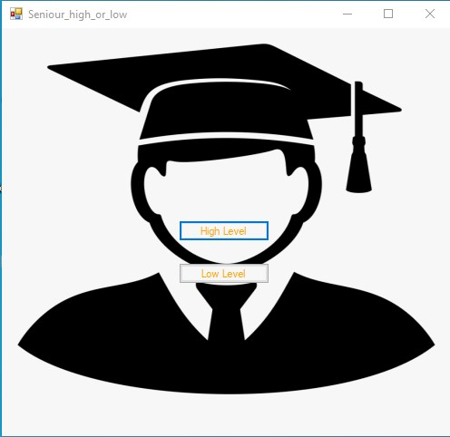

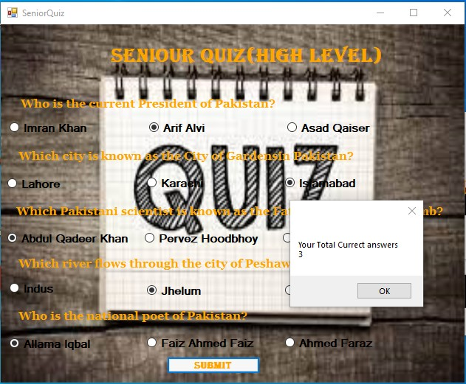

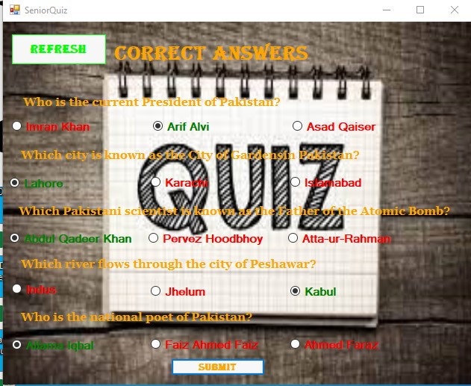

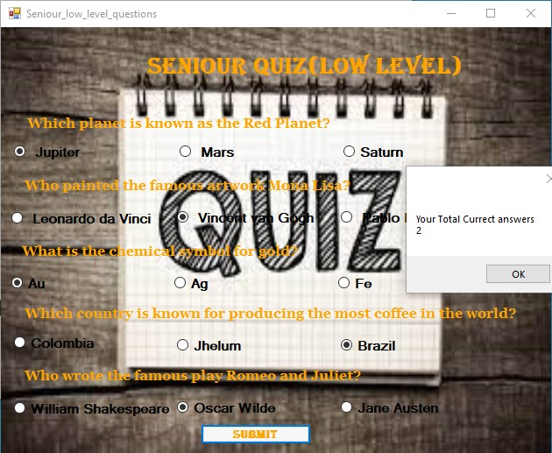

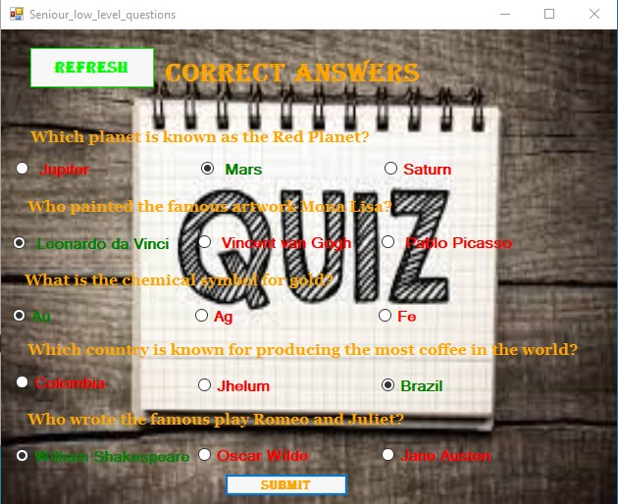

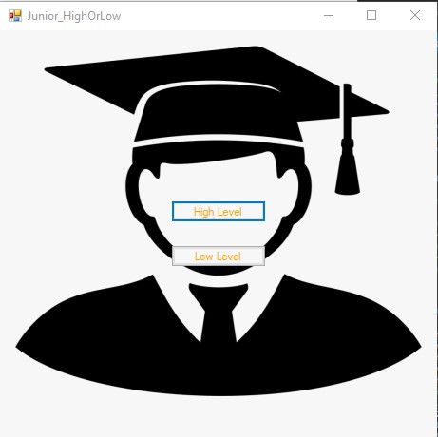

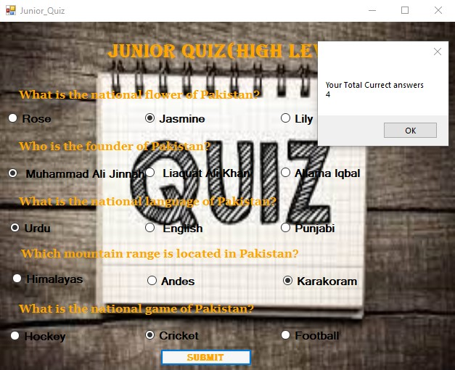

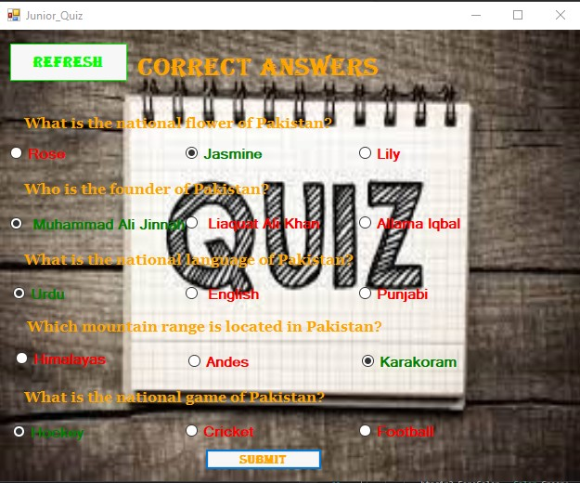

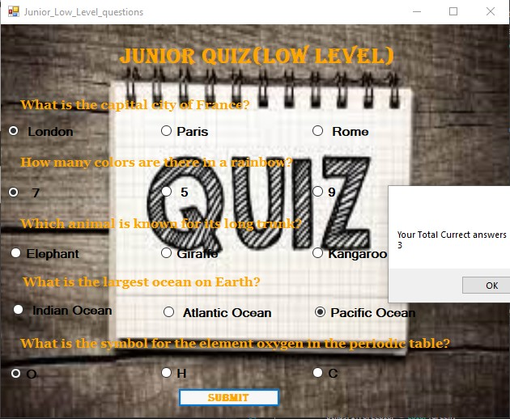

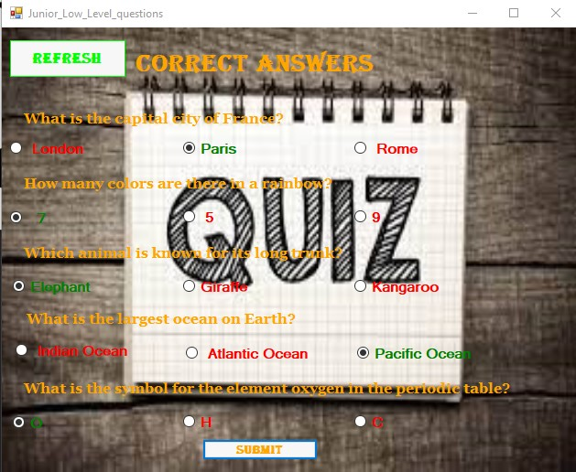

**Code**

using System;

using System.Collections.Generic;

using System.ComponentModel;

using System.Data;

using System.Drawing;

using System.Linq;

using System.Text;

using System.Threading.Tasks;

using System.Windows.Forms;

namespace Question_1

{

public partial class Form1 : Form

{

public Form1()

{

InitializeComponent();

}

private void label1_Click(object sender, EventArgs e)

{

}

private void BtnSenior_Click(object sender, EventArgs e)

{

Seniour_high_or_low sn = new Seniour_high_or_low();

sn.Show();

}

private void btnjunior_Click(object sender, EventArgs e)

{

Junior_HighOrLow j = new Junior_HighOrLow();

j.Show();

}

}

}

Senior Selection

using System;

using System.Collections.Generic;

using System.ComponentModel;

using System.Data;

using System.Drawing;

using System.Linq;

using System.Text;

using System.Threading.Tasks;

using System.Windows.Forms;

namespace Question_1

{

public partial class Seniour_high_or_low : Form

{

public Seniour_high_or_low()

{

InitializeComponent();

}

private void Seniour_high_or_low_Load(object sender, EventArgs e)

{

}

private void High_Level_Click(object sender, EventArgs e)

{

this.Close();

SeniorQuiz sn = new SeniorQuiz();

sn.Show();

}

private void Low_level_Click(object sender, EventArgs e)

{

Seniour_low_level_questions snl = new Seniour_low_level_questions();

snl.Show();

}

}

}

using System;

using System.Collections.Generic;

using System.ComponentModel;

using System.Data;

using System.Drawing;

using System.Linq;

using System.Text;

using System.Threading.Tasks;

using System.Windows.Forms;

namespace Question_1

{

public partial class SeniorQuiz : Form

{

private void btnrefresh_Click(object sender, EventArgs e)

{

this.Close();

SeniorQuiz sn = new SeniorQuiz();

sn.Show();

}

private void btnsubmit_Click(object sender, EventArgs e)

{

if (btnq1r2.Checked == true) { Seniour_student_Data.count++; }

if (btnq2r1.Checked == true) { Seniour_student_Data.count++; }

if (btnq3r1.Checked == true) { Seniour_student_Data.count++; }

if (btnq4r3.Checked == true) { Seniour_student_Data.count++; }

if (btnq5r1.Checked == true) { Seniour_student_Data.count++; }

MessageBox.Show("Your Total Currect answers \n" + Seniour_student_Data.count.ToString());

label1.Text = "Correct Answers";

btnq1r2.Checked = true;

btnq2r1.Checked = true;

btnq3r1.Checked = true;

btnq4r3.Checked = true;

btnq5r1.Checked = true;

btnq1r2.ForeColor = Color.Green;

btnq2r1.ForeColor = Color.Green;

btnq3r1.ForeColor = Color.Green;

btnq4r3.ForeColor = Color.Green;

btnq5r1.ForeColor = Color.Green;

btnq1r1.ForeColor = Color.Red;

btnq1r3.ForeColor = Color.Red;

btnq2r2.ForeColor = Color.Red;

btnq2r3.ForeColor = Color.Red;

btnq3r2.ForeColor = Color.Red;

btnq3r3.ForeColor = Color.Red;

btnq4r1.ForeColor = Color.Red;

btnq4r2.ForeColor = Color.Red;

btnq5r2.ForeColor = Color.Red;

btnq5r3.ForeColor = Color.Red;

btnrefresh.Show();

}

public SeniorQuiz()

{

InitializeComponent();

Seniour_student_Data.Q1= "Who is the current President of Pakistan?";

Seniour_student_Data.Q2 = "Which city is known as the City of Gardensin Pakistan?";

Seniour_student_Data.Q3 = "Which Pakistani scientist is known as the Father of the Atomic Bomb?";

Seniour_student_Data.Q4 = "Which river flows through the city of Peshawar?";

Seniour_student_Data.Q5 = "Who is the national poet of Pakistan?";

Seniour_student_Data.q1o1 = "Imran Khan"; Seniour_student_Data.q1o2 = "Arif Alvi"; Seniour_student_Data.q1o3 = "Asad Qaiser";

Seniour_student_Data.q2o1 = "Lahore"; Seniour_student_Data.q2o2 = "Karachi"; Seniour_student_Data.q2o3 = "Islamabad";

Seniour_student_Data.q3o1 = "Abdul Qadeer Khan"; Seniour_student_Data.q3o2 = "Pervez Hoodbhoy"; Seniour_student_Data.q3o3 = "Atta-ur-Rahman";

Seniour_student_Data.q4o1 = "Indus"; Seniour_student_Data.q4o2 = "Jhelum"; Seniour_student_Data.q4o3 = "Kabul";

Seniour_student_Data.q5o1 = "Allama Iqbal"; Seniour_student_Data.q5o2 = "Faiz Ahmed Faiz"; Seniour_student_Data.q5o3 = "Ahmed Faraz";

SeniorQuiz sn = new SeniorQuiz(

new string[] { Seniour_student_Data.q1o1, Seniour_student_Data.q1o2, Seniour_student_Data.q1o3 },

new string[] { Seniour_student_Data.q2o1, Seniour_student_Data.q2o2, Seniour_student_Data.q2o3 },

new string[] { Seniour_student_Data.q3o1, Seniour_student_Data.q3o2, Seniour_student_Data.q3o3 },

new string[] { Seniour_student_Data.q4o1, Seniour_student_Data.q4o2, Seniour_student_Data.q4o3 },

new string[] { Seniour_student_Data.q5o1, Seniour_student_Data.q5o2, Seniour_student_Data.q5o3 }

);

}

public SeniorQuiz(string[] Q1, string[] Q2, string[] Q3, string[] Q4, string[] Q5)

{

for(int i = 0; i < 3; i++)

{

Seniour_student_Data.O1[i] = Q1[i];

Seniour_student_Data.O2[i] = Q2[i];

Seniour_student_Data.O3[i] = Q3[i];

Seniour_student_Data.O4[i] = Q4[i];

Seniour_student_Data.O5[i] = Q5[i];

}

}

private void question1_Click(object sender, EventArgs e)

{

}

private void SeniorQuiz_Load(object sender, EventArgs e)

{

question1.Text = Seniour_student_Data.Q1;

question1.Show();

question2.Text = Seniour_student_Data.Q2;question2.Show();

question3.Text = Seniour_student_Data.Q3;question3.Show();

question4.Text = Seniour_student_Data.Q4; question4.Show();

question5.Text = Seniour_student_Data.Q5; question5.Show();

btnq1r1.Text = Seniour_student_Data.O1[0];

btnq1r2.Text = Seniour_student_Data.O1[1];

btnq1r3.Text = Seniour_student_Data.O1[2];

btnq2r1.Text = Seniour_student_Data.O2[0];

btnq2r2.Text = Seniour_student_Data.O2[1];

btnq2r3.Text = Seniour_student_Data.O2[2];

btnq3r1.Text = Seniour_student_Data.O3[0];

btnq3r2.Text = Seniour_student_Data.O3[1];

btnq3r3.Text = Seniour_student_Data.O3[2];

btnq4r1.Text = Seniour_student_Data.O4[0];

btnq4r2.Text = Seniour_student_Data.O4[1];

btnq4r3.Text = Seniour_student_Data.O4[2];

btnq5r1.Text = Seniour_student_Data.O5[0];

btnq5r2.Text = Seniour_student_Data.O5[1];

btnq5r3.Text = Seniour_student_Data.O5[2];

}

}

}

using System;

using System.Collections.Generic;

using System.ComponentModel;

using System.Data;

using System.Drawing;

using System.Linq;

using System.Text;

using System.Threading.Tasks;

using System.Windows.Forms;

namespace Question_1

{

public partial class Seniour_low_level_questions : Form

{

public Seniour_low_level_questions()

{

InitializeComponent();

Seniour_student_Data.Q1 = "Which planet is known as the Red Planet?";

Seniour_student_Data.Q2 = "Who painted the famous artwork Mona Lisa?";

Seniour_student_Data.Q3 = "What is the chemical symbol for gold?";

Seniour_student_Data.Q4 = "Which country is known for producing the most coffee in the world?";

Seniour_student_Data.Q5 = "Who wrote the famous play Romeo and Juliet?";

Seniour_student_Data.q1o1 = " Jupiter"; Seniour_student_Data.q1o2 = " Mars"; Seniour_student_Data.q1o3 = "Saturn";

Seniour_student_Data.q2o1 = " Leonardo da Vinci "; Seniour_student_Data.q2o2 = " Vincent van Gogh"; Seniour_student_Data.q2o3 = " Pablo Picasso";

Seniour_student_Data.q3o1 = "Au"; Seniour_student_Data.q3o2 = "Ag"; Seniour_student_Data.q3o3 = "Fe";

Seniour_student_Data.q4o1 = "Colombia"; Seniour_student_Data.q4o2 = "Jhelum"; Seniour_student_Data.q4o3 = "Brazil ";

Seniour_student_Data.q5o1 = "William Shakespeare "; Seniour_student_Data.q5o2 = "Oscar Wilde"; Seniour_student_Data.q5o3 = "Jane Austen";

Seniour_low_level_questions sn = new Seniour_low_level_questions(

new string[] { Seniour_student_Data.q1o1, Seniour_student_Data.q1o2, Seniour_student_Data.q1o3 },

new string[] { Seniour_student_Data.q2o1, Seniour_student_Data.q2o2, Seniour_student_Data.q2o3 },

new string[] { Seniour_student_Data.q3o1, Seniour_student_Data.q3o2, Seniour_student_Data.q3o3 },

new string[] { Seniour_student_Data.q4o1, Seniour_student_Data.q4o2, Seniour_student_Data.q4o3 },

new string[] { Seniour_student_Data.q5o1, Seniour_student_Data.q5o2, Seniour_student_Data.q5o3 });

}

public Seniour_low_level_questions(string[] Q1, string[] Q2, string[] Q3, string[] Q4, string[] Q5)

{

for (int i = 0; i < 3; i++)

{

Seniour_student_Data.O1[i] = Q1[i];

Seniour_student_Data.O2[i] = Q2[i];

Seniour_student_Data.O3[i] = Q3[i];

Seniour_student_Data.O4[i] = Q4[i];

Seniour_student_Data.O5[i] = Q5[i];

}

}

private void Seniour_low_level_questions_Load(object sender, EventArgs e)

{

question1.Text = Seniour_student_Data.Q1;

question1.Show();

question2.Text = Seniour_student_Data.Q2; question2.Show();

question3.Text = Seniour_student_Data.Q3; question3.Show();

question4.Text = Seniour_student_Data.Q4; question4.Show();

question5.Text = Seniour_student_Data.Q5; question5.Show();

btnq1r1.Text = Seniour_student_Data.O1[0];

btnq1r2.Text = Seniour_student_Data.O1[1];

btnq1r3.Text = Seniour_student_Data.O1[2];

btnq2r1.Text = Seniour_student_Data.O2[0];

btnq2r2.Text = Seniour_student_Data.O2[1];

btnq2r3.Text = Seniour_student_Data.O2[2];

btnq3r1.Text = Seniour_student_Data.O3[0];

btnq3r2.Text = Seniour_student_Data.O3[1];

btnq3r3.Text = Seniour_student_Data.O3[2];

btnq4r1.Text = Seniour_student_Data.O4[0];

btnq4r2.Text = Seniour_student_Data.O4[1];

btnq4r3.Text = Seniour_student_Data.O4[2];

btnq5r1.Text = Seniour_student_Data.O5[0];

btnq5r2.Text = Seniour_student_Data.O5[1];

btnq5r3.Text = Seniour_student_Data.O5[2];

}

private void btnsubmit_Click(object sender, EventArgs e)

{

if (btnq1r2.Checked == true) { Seniour_student_Data.count++; }

if (btnq2r1.Checked == true) { Seniour_student_Data.count++; }

if (btnq3r1.Checked == true) { Seniour_student_Data.count++; }

if (btnq4r3.Checked == true) { Seniour_student_Data.count++; }

if (btnq5r1.Checked == true) { Seniour_student_Data.count++; }

MessageBox.Show("Your Total Currect answers \n" + Seniour_student_Data.count.ToString());

label1.Text = "Correct Answers";

btnq1r2.Checked = true;

btnq2r1.Checked = true;

btnq3r1.Checked = true;

btnq4r3.Checked = true;

btnq5r1.Checked = true;

btnq1r2.ForeColor = Color.Green;

btnq2r1.ForeColor = Color.Green;

btnq3r1.ForeColor = Color.Green;

btnq4r3.ForeColor = Color.Green;

btnq5r1.ForeColor = Color.Green;

btnq1r1.ForeColor = Color.Red;

btnq1r3.ForeColor = Color.Red;

btnq2r2.ForeColor = Color.Red;

btnq2r3.ForeColor = Color.Red;

btnq3r2.ForeColor = Color.Red;

btnq3r3.ForeColor = Color.Red;

btnq4r1.ForeColor = Color.Red;

btnq4r2.ForeColor = Color.Red;

btnq5r2.ForeColor = Color.Red;

btnq5r3.ForeColor = Color.Red;

btnrefresh.Show();

}

private void btnrefresh_Click(object sender, EventArgs e)

{

this.Close();

Seniour_low_level_questions sn = new Seniour_low_level_questions();

sn.Show();

}

}

}

**Junior Selection**

using System;

using System.Collections.Generic;

using System.ComponentModel;

using System.Data;

using System.Drawing;

using System.Linq;

using System.Text;

using System.Threading.Tasks;

using System.Windows.Forms;

namespace Question_1

{

public partial class Junior_HighOrLow : Form

{

public Junior_HighOrLow()

{

InitializeComponent();

}

private void High_Level_Click(object sender, EventArgs e)

{

Junior_Quiz jn = new Junior_Quiz();

this.Close();

jn.Show();

}

private void Low_level_Click(object sender, EventArgs e)

{

Junior_Low_Level_questions jn = new Junior_Low_Level_questions();

this.Close();

jn.Show();

}

}

}

using System;

using System.Collections.Generic;

using System.ComponentModel;

using System.Data;

using System.Drawing;

using System.Linq;

using System.Text;

using System.Threading.Tasks;

using System.Windows.Forms;

namespace Question_1

{

public partial class Junior_Quiz : Form

{

public Junior_Quiz()

{

InitializeComponent();

Juniour_student_data.Q1 = "What is the national flower of Pakistan?";

Juniour_student_data.Q2 = "Who is the founder of Pakistan?";

Juniour_student_data.Q3 = "What is the national language of Pakistan?";

Juniour_student_data.Q4 = "Which mountain range is located in Pakistan?";

Juniour_student_data.Q5 = "What is the national game of Pakistan?";

Juniour_student_data.q1o1 = "Rose"; Juniour_student_data.q1o2 = "Jasmine"; Juniour_student_data.q1o3 = "Lily";

Juniour_student_data.q2o1 = " Muhammad Ali Jinnah"; Juniour_student_data.q2o2 = " Liaquat Ali Khan"; Juniour_student_data.q2o3 = "Allama Iqbal";

Juniour_student_data.q3o1 = "Urdu"; Juniour_student_data.q3o2 = " English"; Juniour_student_data.q3o3 = "Punjabi";

Juniour_student_data.q4o1 = "Himalayas"; Juniour_student_data.q4o2 = "Andes"; Juniour_student_data.q4o3 = "Karakoram";

Juniour_student_data.q5o1 = "Hockey"; Juniour_student_data.q5o2 = "Cricket"; Juniour_student_data.q5o3 = "Football";

Junior_Quiz sn = new Junior_Quiz(

new string[] { Juniour_student_data.q1o1, Juniour_student_data.q1o2, Juniour_student_data.q1o3 },

new string[] { Juniour_student_data.q2o1, Juniour_student_data.q2o2, Juniour_student_data.q2o3 },

new string[] { Juniour_student_data.q3o1, Juniour_student_data.q3o2, Juniour_student_data.q3o3 },

new string[] { Juniour_student_data.q4o1, Juniour_student_data.q4o2, Juniour_student_data.q4o3 },

new string[] { Juniour_student_data.q5o1, Juniour_student_data.q5o2, Juniour_student_data.q5o3 });

}

public Junior_Quiz(string[] Q1, string[] Q2, string[] Q3, string[] Q4, string[] Q5)

{

for (int i = 0; i < 3; i++)

{

Juniour_student_data.O1[i] = Q1[i];

Juniour_student_data.O2[i] = Q2[i];

Juniour_student_data.O3[i] = Q3[i];

Juniour_student_data.O4[i] = Q4[i];

Juniour_student_data.O5[i] = Q5[i];

}

}

private void btnrefresh_Click(object sender, EventArgs e)

{

this.Close();

SeniorQuiz sn = new SeniorQuiz();

sn.Show();

}

private void label1_Click(object sender, EventArgs e)

{

}

private void btnsubmit_Click(object sender, EventArgs e)

{

if (btnq1r2.Checked == true) { Juniour_student_data.count++; }

if (btnq2r1.Checked == true) { Juniour_student_data.count++; }

if (btnq3r1.Checked == true) { Juniour_student_data.count++; }

if (btnq4r3.Checked == true) { Juniour_student_data.count++; }

if (btnq5r1.Checked == true) { Juniour_student_data.count++; }

MessageBox.Show("Your Total Currect answers \n" + Juniour_student_data.count.ToString());

label1.Text = "Correct Answers";

btnq1r2.Checked = true;

btnq2r1.Checked = true;

btnq3r1.Checked = true;

btnq4r3.Checked = true;

btnq5r1.Checked = true;

btnq1r2.ForeColor = Color.Green;

btnq2r1.ForeColor = Color.Green;

btnq3r1.ForeColor = Color.Green;

btnq4r3.ForeColor = Color.Green;

btnq5r1.ForeColor = Color.Green;

btnq1r1.ForeColor = Color.Red;

btnq1r3.ForeColor = Color.Red;

btnq2r2.ForeColor = Color.Red;

btnq2r3.ForeColor = Color.Red;

btnq3r2.ForeColor = Color.Red;

btnq3r3.ForeColor = Color.Red;

btnq4r1.ForeColor = Color.Red;

btnq4r2.ForeColor = Color.Red;

btnq5r2.ForeColor = Color.Red;

btnq5r3.ForeColor = Color.Red;

btnrefresh.Show();

}

private void Junior_Quiz_Load(object sender, EventArgs e)

{

question1.Text = Juniour_student_data.Q1;

question1.Show();

question2.Text = Juniour_student_data.Q2; question2.Show();

question3.Text = Juniour_student_data.Q3; question3.Show();

question4.Text = Juniour_student_data.Q4; question4.Show();

question5.Text = Juniour_student_data.Q5; question5.Show();

btnq1r1.Text = Juniour_student_data.O1[0];

btnq1r2.Text = Juniour_student_data.O1[1];

btnq1r3.Text = Juniour_student_data.O1[2];

btnq2r1.Text = Juniour_student_data.O2[0];

btnq2r2.Text = Juniour_student_data.O2[1];

btnq2r3.Text = Juniour_student_data.O2[2];

btnq3r1.Text = Juniour_student_data.O3[0];

btnq3r2.Text = Juniour_student_data.O3[1];

btnq3r3.Text = Juniour_student_data.O3[2];

btnq4r1.Text = Juniour_student_data.O4[0];

btnq4r2.Text = Juniour_student_data.O4[1];

btnq4r3.Text = Juniour_student_data.O4[2];

btnq5r1.Text = Juniour_student_data.O5[0];

btnq5r2.Text = Juniour_student_data.O5[1];

btnq5r3.Text = Juniour_student_data.O5[2];

}

}

}

using System;

using System.Collections.Generic;

using System.ComponentModel;

using System.Data;

using System.Drawing;

using System.Linq;

using System.Text;

using System.Threading.Tasks;

using System.Windows.Forms;

namespace Question_1

{

public partial class Junior_Low_Level_questions : Form

{

public Junior_Low_Level_questions()

{

InitializeComponent();

Juniour_student_data.Q1 = "What is the capital city of France?";

Juniour_student_data.Q2 = "How many colors are there in a rainbow?";

Juniour_student_data.Q3 = "Which animal is known for its long trunk?";

Juniour_student_data.Q4 = "What is the largest ocean on Earth?";

Juniour_student_data.Q5 = "What is the symbol for the element oxygen in the periodic table?";

Juniour_student_data.q1o1 = " London"; Juniour_student_data.q1o2 = "Paris"; Juniour_student_data.q1o3 = " Rome";

Juniour_student_data.q2o1 = " 7"; Juniour_student_data.q2o2 = " 5"; Juniour_student_data.q2o3 = "9";

Juniour_student_data.q3o1 = "Elephant "; Juniour_student_data.q3o2 = "Giraffe"; Juniour_student_data.q3o3 = "Kangaroo";

Juniour_student_data.q4o1 = " Indian Ocean"; Juniour_student_data.q4o2 = " Atlantic Ocean"; Juniour_student_data.q4o3 = "Pacific Ocean";

Juniour_student_data.q5o1 = "O"; Juniour_student_data.q5o2 = "H"; Juniour_student_data.q5o3 = "C";

Junior_Quiz sn = new Junior_Quiz(

new string[] { Juniour_student_data.q1o1, Juniour_student_data.q1o2, Juniour_student_data.q1o3 },

new string[] { Juniour_student_data.q2o1, Juniour_student_data.q2o2, Juniour_student_data.q2o3 },

new string[] { Juniour_student_data.q3o1, Juniour_student_data.q3o2, Juniour_student_data.q3o3 },

new string[] { Juniour_student_data.q4o1, Juniour_student_data.q4o2, Juniour_student_data.q4o3 },

new string[] { Juniour_student_data.q5o1, Juniour_student_data.q5o2, Juniour_student_data.q5o3 });

}

public Junior_Low_Level_questions(string[] Q1, string[] Q2, string[] Q3, string[] Q4, string[] Q5)

{

for (int i = 0; i < 3; i++)

{

Juniour_student_data.O1[i] = Q1[i];

Juniour_student_data.O2[i] = Q2[i];

Juniour_student_data.O3[i] = Q3[i];

Juniour_student_data.O4[i] = Q4[i];

Juniour_student_data.O5[i] = Q5[i];

}

}

private void btnsubmit_Click(object sender, EventArgs e)

{

if (btnq1r2.Checked == true) { Juniour_student_data.count++; }

if (btnq2r1.Checked == true) { Juniour_student_data.count++; }

if (btnq3r1.Checked == true) { Juniour_student_data.count++; }

if (btnq4r3.Checked == true) { Juniour_student_data.count++; }

if (btnq5r1.Checked == true) { Juniour_student_data.count++; }

MessageBox.Show("Your Total Currect answers \n"+Juniour_student_data.count.ToString());

label1.Text = "Correct Answers";

btnq1r2.Checked = true;

btnq2r1.Checked = true;

btnq3r1.Checked = true;

btnq4r3.Checked = true;

btnq5r1.Checked = true;

btnq1r2.ForeColor = Color.Green;

btnq2r1.ForeColor = Color.Green;

btnq3r1.ForeColor = Color.Green;

btnq4r3.ForeColor = Color.Green;

btnq5r1.ForeColor = Color.Green;

btnq1r1.ForeColor = Color.Red;

btnq1r3.ForeColor = Color.Red;

btnq2r2.ForeColor = Color.Red;

btnq2r3.ForeColor = Color.Red;

btnq3r2.ForeColor = Color.Red;

btnq3r3.ForeColor = Color.Red;

btnq4r1.ForeColor = Color.Red;

btnq4r2.ForeColor = Color.Red;

btnq5r2.ForeColor = Color.Red;

btnq5r3.ForeColor = Color.Red;

btnrefresh.Show();

}

private void Junior_Low_Level_questions_Load(object sender, EventArgs e)

{

question1.Text = Juniour_student_data.Q1;

question1.Show();

question2.Text = Juniour_student_data.Q2; question2.Show();

question3.Text = Juniour_student_data.Q3; question3.Show();

question4.Text = Juniour_student_data.Q4; question4.Show();

question5.Text = Juniour_student_data.Q5; question5.Show();

btnq1r1.Text = Juniour_student_data.O1[0];

btnq1r2.Text = Juniour_student_data.O1[1];

btnq1r3.Text = Juniour_student_data.O1[2];

btnq2r1.Text = Juniour_student_data.O2[0];

btnq2r2.Text = Juniour_student_data.O2[1];

btnq2r3.Text = Juniour_student_data.O2[2];

btnq3r1.Text = Juniour_student_data.O3[0];

btnq3r2.Text = Juniour_student_data.O3[1];

btnq3r3.Text = Juniour_student_data.O3[2];

btnq4r1.Text = Juniour_student_data.O4[0];

btnq4r2.Text = Juniour_student_data.O4[1];

btnq4r3.Text = Juniour_student_data.O4[2];

btnq5r1.Text = Juniour_student_data.O5[0];

btnq5r2.Text = Juniour_student_data.O5[1];

btnq5r3.Text = Juniour_student_data.O5[2];

}

private void btnrefresh_Click(object sender, EventArgs e)

{

this.Close();

Junior_Low_Level_questions sn = new Junior_Low_Level_questions();

sn.Show();

}

}

}

**Classes**

using System;

using System.Collections.Generic;

using System.Linq;

using System.Text;

using System.Threading.Tasks;

namespace Question_1

{

class Seniour_student_Data

{

public static string Q1, Q2, Q3, Q4, Q5;

public static string q1o1, q1o2, q1o3, q2o1, q2o2, q2o3, q3o1, q3o2, q3o3, q4o1, q4o2, q4o3, q5o1, q5o2, q5o3;

public static string[] O1 = new string[5];

public static string[] O2 = new string[5];

public static string[] O3 = new string[5];

public static string[] O4 = new string[5];

public static string[] O5 = new string[5];

public static int count;

}

}

using System;

using System.Collections.Generic;

using System.Linq;

using System.Text;

using System.Threading.Tasks;

namespace Question_1

{

class Juniour_student_data

{

public static string Q1, Q2, Q3, Q4, Q5;

public static string q1o1, q1o2, q1o3, q2o1, q2o2, q2o3, q3o1, q3o2, q3o3, q4o1, q4o2, q4o3, q5o1, q5o2, q5o3;

public static string[] O1 = new string[5];

public static string[] O2 = new string[5];

public static string[] O3 = new string[5];

public static string[] O4 = new string[5];

public static string[] O5 = new string[5];

public static int count;

}

}

**Question – 2 [CONSOLE BASED ] [5 mark]**

Perform the following question and apply appropriate OOP concept.

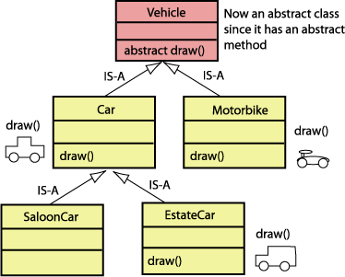

Code:

using System;

using System.Collections.Generic;

using System.Linq;

using System.Text;

using System.Threading.Tasks;

namespace Question_2

{

public abstract class Vehicle

{

public abstract void Draw();

}

class MotorBike : Vehicle

{

public override void Draw()

{

Console.WriteLine("This Is motorCycle Diagram");

Console.WriteLine("=O====O=");

}

}

class Car : Vehicle

{

public override void Draw()

{

Console.WriteLine("\n\nThis is Car");

Console.WriteLine(" ======= ");

Console.WriteLine("===| |=====");

Console.WriteLine("|_O_________O___|");

}

}

class Saloon : Car

{

public Saloon()

{

base.Draw();

}

}

class EstateCar : Car

{

public override void Draw()

{

Console.WriteLine("\n\nThis is Estate Vihicle");

Console.WriteLine(" ====================== ");

Console.WriteLine(" | |");

Console.WriteLine(" | |");

Console.WriteLine(" | |");

Console.WriteLine(" | |");

Console.WriteLine("=== | ");

Console.WriteLine("|___O_______________O___|");

}

}

class Program

{

static void Main(string[] args)

{

MotorBike m1 = new MotorBike();

m1.Draw();

Saloon s1 = new Saloon();

EstateCar es1 = new EstateCar();

es1.Draw();

}

}

}

